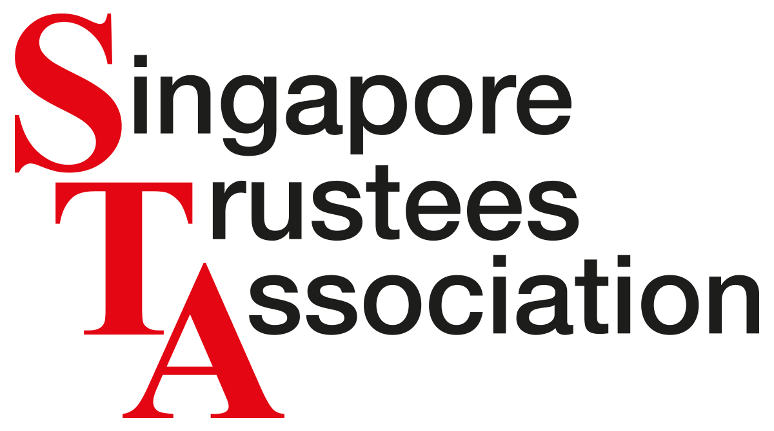




BECOME A SPONSOR, 2018
STA is pleased to invite you to participate as Sponsor of STA Conference 2018

SPONSORSHIP FEE

STA CONFERENCE 2018 SGD 6,000

SPONSORSHIP BENEFITS
Sponsors enjoy the following benefits:

- Opportunity to Exhibit at STA Conference 2018
- 10 Complimentary Passes to STA Conference 2018
- Networking Opportunity at STA Conference 2018
- One table-top display space at Conference 2018 venue
- Logo display on Conference 2018 Flyer as well as marketing collaterals

ENQUIRIES
Kindly contact Gea Ban Peng at +65 6223 9000 or email STAConference@sta.org.sg

www.sta.org.sg

SPONSORSHIP FORM

Name of Institution _________________________________________________________

Address___________________________________________________________________

__________________________________________________________________________

Telephone no. ______________________________________________________________

Email______________________________________________________________________

Contact Person ______________________________________________________________

Designation _________________________________________________________________

Confirmation
This is to confirm that

___________________________________________________________________________
will participate as a Sponsor of STA

______________________________________________________________________
Signature & Name of Authorized Representative/ Company stamp/Date

Sponsorship Fees & Payment
1. The sponsorship fees must be paid in full upon receipt of the invoice.
2. Payment must be made by cheque, payable to “Singapore Trustees Association”
or by bank transfer to:
Name of Account: Singapore Trustees Association
Bank Account No.: 501-584320-001
Swift Code: OCBCSGSG
Bank Details: Overseas-Chinese Banking Corporation Limited (OCBC Centre Branch)
65 Chulia Street, #01-00, OCBC Centre. Singapore 049513
The sponsorship amount must be received nett of all receiving and paying bank charges.
3. Sponsorship is confirmed upon receipt of the sponsorship fees.
4. All completed forms and cheques should be sent to:
Singapore Trustees Association
10 Anson Road, #26-08, International Plaza,
Singapore 079903

Mar 2018

